**EXPRIMENT NO-25**

**CSA1142-OBJECT ORIENTED ANALYSIS AND DESIGN**

**ONLINE VOTING SYSTEM**

**USE CASE**

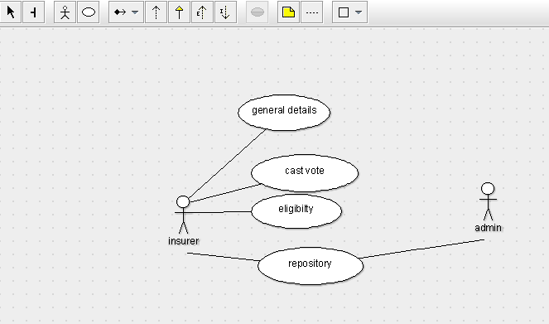

STATE DIAAGRAM

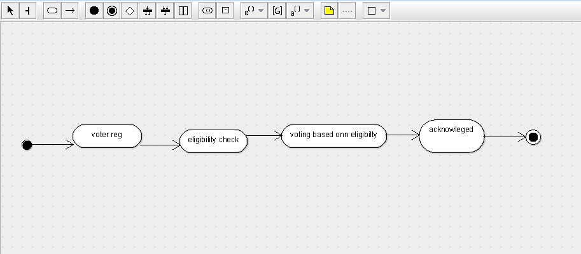

SEQUENCE DIAGRAM

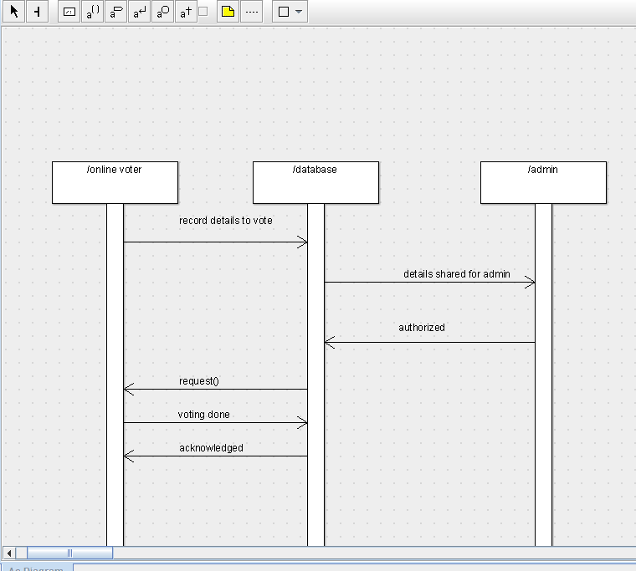

DEPLOYMENT DIAGRAM

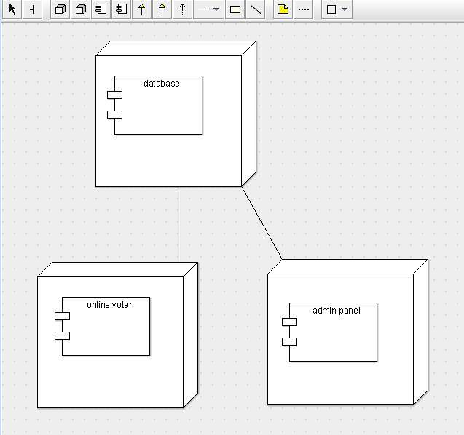

COMPONENT DIAGRAM

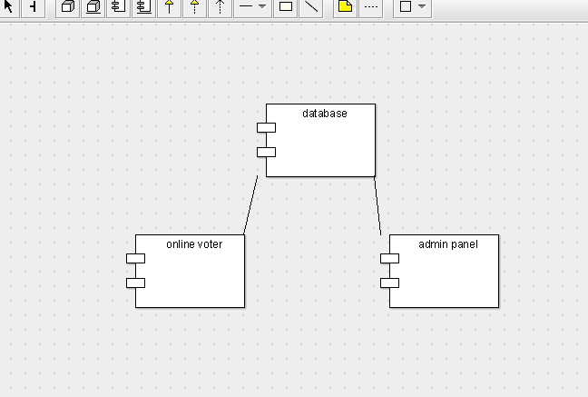

COLLABORATION DIAGRAM

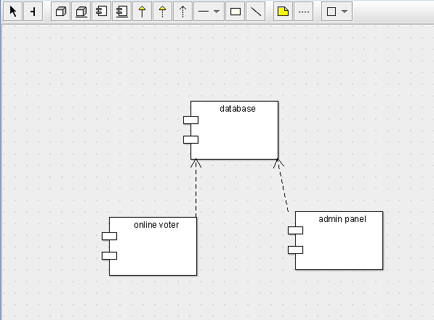

CLASS DIAGRAM

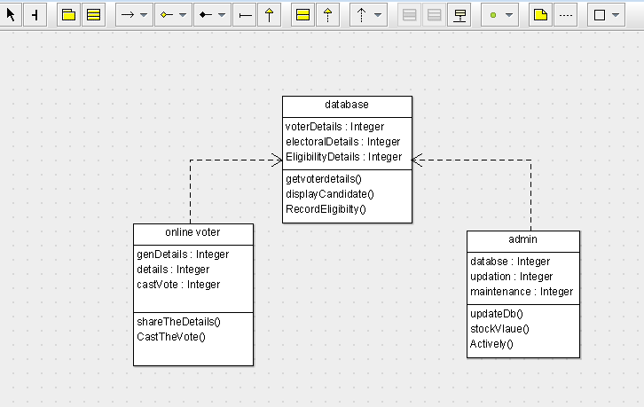

ACTIVITY DIAGRAM

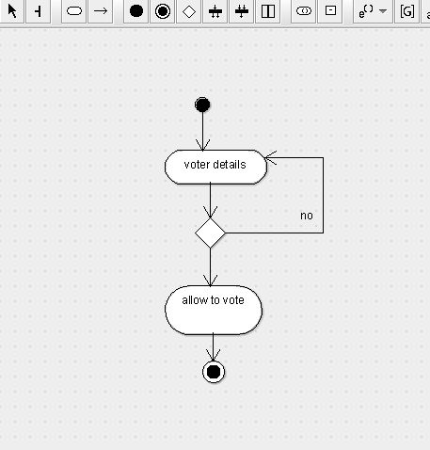public class database {

  public Integer voterDetails;

  public Integer electoralDetails;

  public Integer EligibilityDetails;

  public void getvoterdetails() {

  }

  public void displayCandidate() {

  }

  public void RecordEligibilty() {

  }

}

public class online voter {

  public Integer genDetails;

  public Integer details;

  public Integer castVote;

  public void shareTheDetails() {

  }

  public void CastTheVote() {

  }

}

public class admin {

  public Integer databse;

  public Integer updation;

  public Integer maintenance;

  public void updateDb() {

  }

  public void stockVlaue() {

  }

  public void Actively() {

  }

}

SKELETON CODE;